BASIC NUMBER THREE
(Little Tigers)
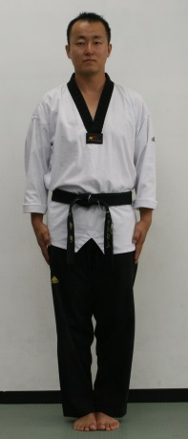 |  | 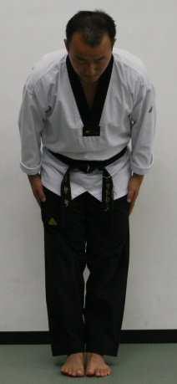 |  |  | 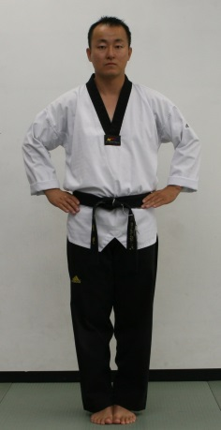 |  | 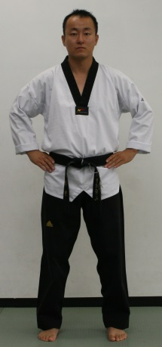 | 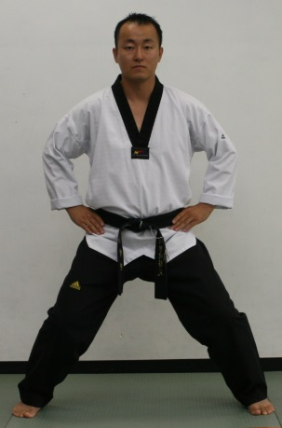
1 |  |  | 2 |  | 3 |  | 4 | 5

Hand side | Bow | Hand on your hips
Attention stance | Attention stance | Attention stance | Ready stance | Horseback stance
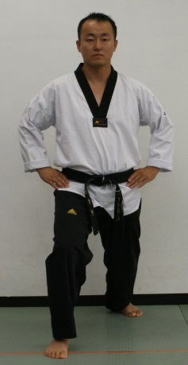
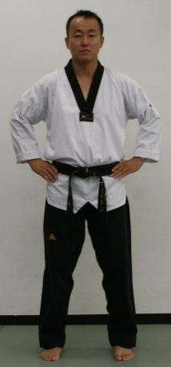
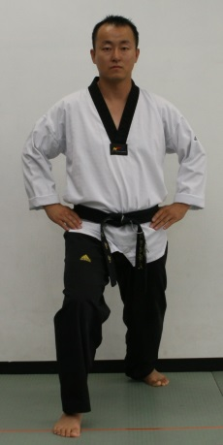
10 | 9 | 8 | 7 | 6

Hand on your side
Attention stance | Ready stance | Long stance | Ready stance | Long stance

Thank you Sir !

Kwon’s Taekwondo Little Tigers Course
White & Orange Stripe Belt

Stances | Attention, Ready stance, Horseback Riding stance, Walking stance, Kicking stance
Blocks | Low block, High block, In block
Strikes | Punch (1,2,3)
Form  (Yellow Stripe) | BASIC NUMBER THREE (3)
Kicking Techniques  (Blue Stripe) | FRONT KICK, AXE KICK
Board Breaking  (Red Stripe) | ELBOW STRIKE
Kicking Combination | 1. Front kick – axe kick  2. Front kick - axe kick - double punch
Korean Terms | 1. What is your master’s name?–Young Min Kwon Sir!  2. What do you learn at this school?–Tae Kwon Do Sir!  3. What is your parents name?  4. What is your parents phone number?  5. SA BUM NIM - Master instructor  6. KAM SA HAM NI DA – Thank you  7. AN NYUNG HA SE YO? - How are you?  8. AN NYUNG HI GEI SE YO – Good- bye  9. CHA RYEOT - Attention  10. KYEUNG NAE - Bow  11. JUN BEE - Ready  12. SHI JAK - Begin  13. BA RO - Return  14. KI HAP - Yelling  15. Korean counting 11 – 20
Testing for White & Green Stripe Belt
Student must have 3 for color tips (Yellow, Blue, Red)

Techniques you will be asked to demonstrate

- Basic stances, strikes, blocks
- Kicking Techniques / Kicking combinations
- BASIC NUMBER THREE (3)
- Breaking Board (Elbow Strike)
- Korean Terms / Physical Fitness (15 Push up, 15 Sit up)

