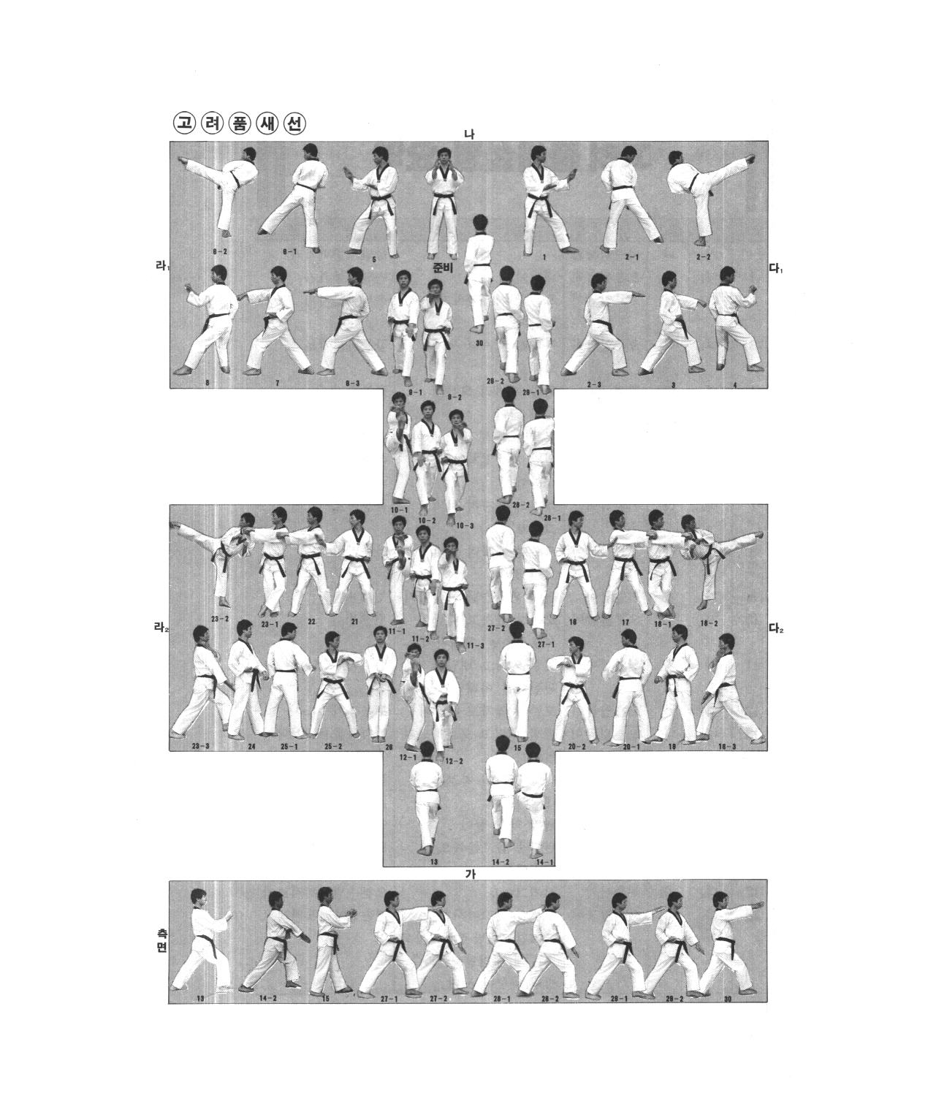
1st Black Belt Form
Ko-Ryo

