**4th Black Belt**

**Pyong-Won**

[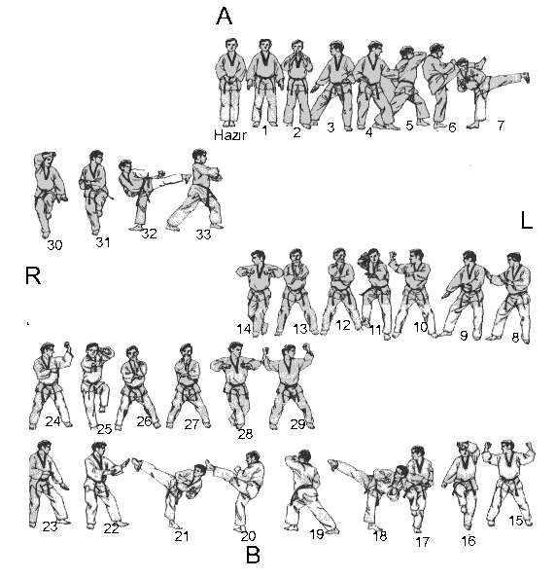](http://www.google.com/url?sa=i&rct=j&q=&esrc=s&frm=1&source=images&cd=&cad=rja&docid=_ANKacNllDngNM&tbnid=mpktfZQ9isqoEM:&ved=0CAUQjRw&url=http://www.pic2fly.com/Pyongwon+Form.html&ei=4DkZUa-xIoyt0AGCu4C4BQ&bvm=bv.42080656,d.dmQ&psig=AFQjCNGPmSh-5LbKKvb7VXCbabJHm74GSA&ust=1360694007622341)