**8th Black Belt**

**Il-yo**

[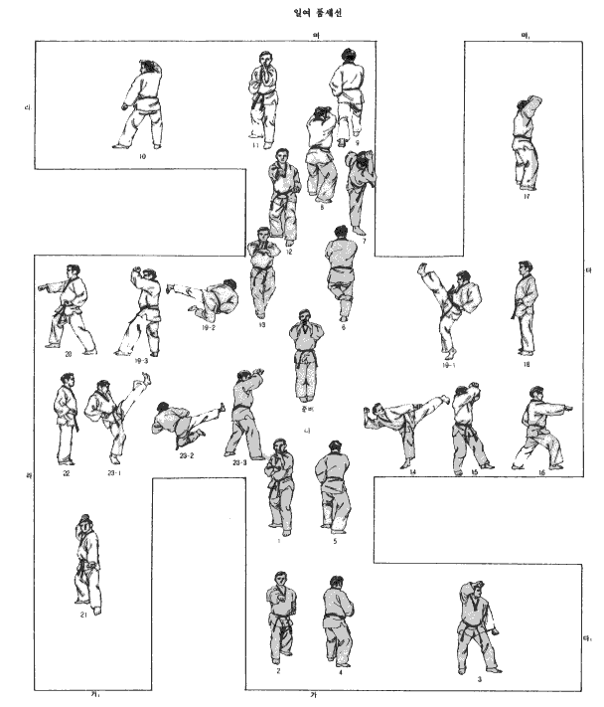](http://www.google.com/url?sa=i&rct=j&q=&esrc=s&frm=1&source=images&cd=&cad=rja&docid=yBjzES3S-0nskM&tbnid=tXdxYjERSeK95M:&ved=0CAUQjRw&url=http://www.budopedia.org/wiki/index.php?title=Ilyo&ei=Cj8ZUZ2xEcXG0AGn8YHoBg&bvm=bv.42080656,d.dmQ&psig=AFQjCNGSKkcn5a_IJGZIOQxvOu1HSDbrJw&ust=1360695426214419)