KI BON HA NA (기본 하나)
White & Blue S
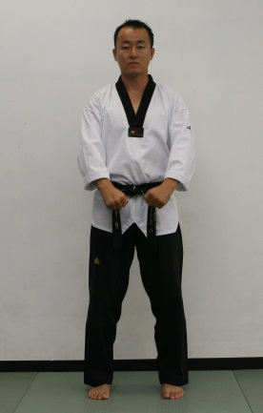 | 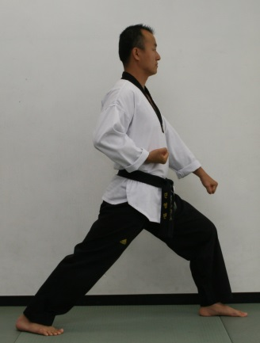 |  | 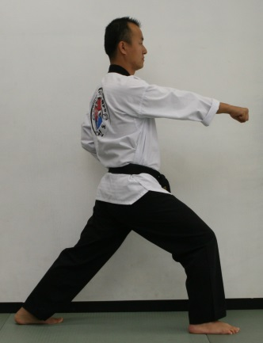 |  | 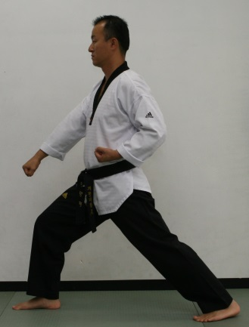
1 | 2 |  | 3 |  | 4
 |  | Low block |  | Middle punch | Low block
Ready |  | Long stance |  | Long stance | Long stance

 | 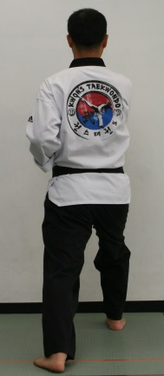 |  | 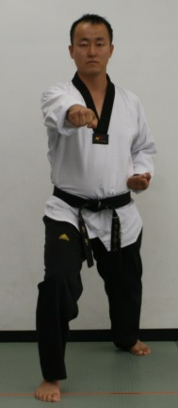 | 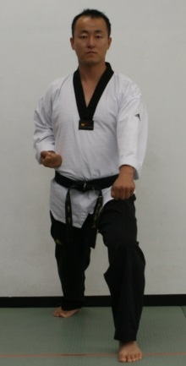 | 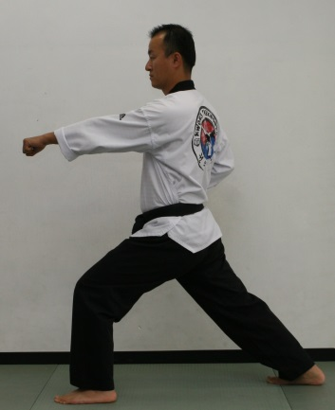
 | 9 | 8 | 7 | 6 | 5
Middle punch |  | Low block | Middle punch | Low block |  | Middle punch
Long stance |  | Long stance | Long stance | Long stance |  | Long stance
KI HAP (Yelling)

 |  | 8,9
4,5 | 10
 |  | 1 | 2,3
 |  |  |  |  |  | 10
 | 6,7 |  |  |  |  | Ready stance

Kwon’s Taekwondo Little Tigers Course
White & Green Stripe Belt
Stances | Attention, Ready stance, Horseback riding stance, Walking stance, Kicking stance, Long stance
Blocks | Low block, High block, In block, Out block
Strikes | Punch (1,2,3), Knuckle fist, Spear finger, Knife hand, Back fist
Form  (Yellow Stripe) | BASIC NUMBER ONE, TWO, THREE (1, 2, 3)
Kicking Techniques  (Blue Stripe) | ROUNDHOUSE KICK
Board Breaking  (Red Stripe) | ONE HAND and ONE KICK
Kicking Combination | 1. Roundhouse kick - Front kick  2. Roundhouse kick - axe kick  3. Roundhouse kick - front kick - axe kick
Korean Terms | 1. What is your master’s name?–Young Min Kwon Sir!  2. What do you learn at this school?–Tae Kwon Do Sir!  3. What is your parents name?  4. What is your parents phone number?  5. SA BUM NIM - Master instructor  6. KAM SA HAM NI DA – Thank you  7. AN NYUNG HA SE YO? - How are you?  8. AN NYUNG HI GEI SE YO – Good bye  9. CHA RYEOT - Attention  10. KYEUNG NAE - Bow  11. JUN BEE - Ready  12. SHI JAK - Begin  13. BA RO - Return  14. KI HAP - Yelling  15. Korean counting 11 – 20
Testing for White & Purple Stripe Belt
Student must have 4 for color tips (White, Yellow, Blue, Red)
Techniques you will be asked to demonstrate
- Basic stances, strikes, blocks
- Kicking Techniques / Kicking combinations
- BASIC NUMBER ONE, TWO, THREE (1, 2, 3)
- Breaking Board (One hand, One kick)
- Korean Terms / Physical Fitness (15 Push up, 15 Sit up)

